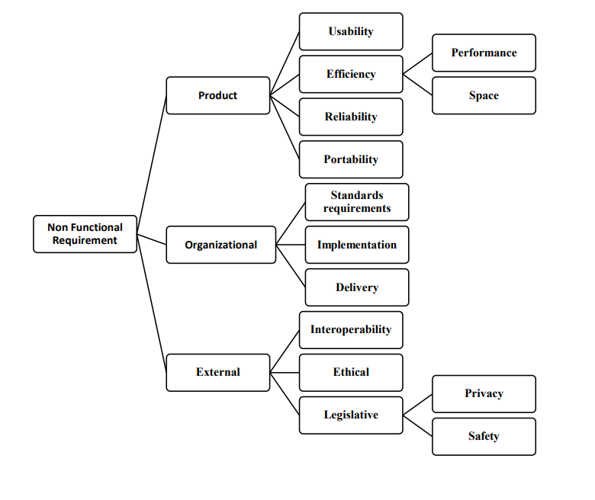**Question 1:** For each type of Non Functional Requirements give two example each and identify Goal, Objective and Quantitative verifiable metric where possible to create proper non-functional statements.

Name : Mutayyab Imran

Enrollnment # : 02-131212-063

Registration # : 79315

Subject : Software Requirement Engineering

**NON-FUNCTIONAL REQUIREMENTS:**

* **PRODUCT:**

Requirements which specify how software product performs that is the delivered product must behave in a particular way.

**Examples:** execution speed, reliability.

**Goal:** User-friendly

**Objective:** Users can check errors or change detail in a specific time.

* **ORGANIZATIONAL:**

Constraints placed upon the development process of the system, which are consequence of organizational policies and procedures in the customer’s and developer's organization.

**Examples:** delivery, implementation etc.

**Goal:** User-attractive.

**Objective:** User cannot being loss by understanding the advantages and detail of different features of product.

* **EXTERNAL:**

Requirements which arise from factors which affect the system and its development process externally.

**Examples:** Legislative requirements, ethical etc.

**Goal:** User Verification.

**Objective:** User details and accounts must be saved.

* **USABILITY:**

Usability is classical non-functional requirement that addresses a simple question:

How hard is it to use the product?

**Example**: The error rate of users submitting their payment details at the checkout page mustn’t exceed 10 percent.

**Another example:** if the server down during shopping it must be recover in 1second.

**Goal**: User-friendly.

**Objective**: User can correct or change detail in a specific time.

**Metrics**: Training time, mouse clicks.

* **EFFICIENCY:**

Defines how fast a software system or its particular piece responds to certain users’ actions under certain workload.

**Performance Example:**

The landing page supporting 5 thousand users per hour must provide 6 seconds or less response time in a Chrome desktop browser.

**Space example:**

if you develop an online shopping mobile application it must take very low storage because all the users haven’t costly or expensive phones.

**Goal**: Efficient product.

**Objective**: Users cannot get interrupt by using that software.

**Metrics (space):** Main memory.

**Metrics (time):** response time, time to complete an information.

* **RELIABILITY:**

This quality attribute specifies how likely the system or its element would run without a failure for a given period of time under predefined conditions

**Reliability example:**

If the website is crash during most traffic of users, then it will must be recovered in minimum time e.g. 1-Second.

**Second example:** Only one percent ofchances when users use the website.

**Goal:** Failure free product.

**Objective:** Large number of users use that product at same time.

**Metrics:** Mean time to failure, failure rate, availability.

* **PORTABILITY:**

defines how a system or its element can be launched on one environment or another. It usually includes hardware, software, or other usage platform specification.

**Example:** The iOS application must support iPhone devices running on OS versions:

* 3.6
* 3.3
* 3.4
* 4.3
* 2.3

**Another Example:** If A Web Application Works On Windows, It Should Work Same On The Linux.

**Goal:** Product availability.

**Objective:** Users can use product in all devices.

**Metrics:** Number of systems where software can run.

* **STANDARD REQUIREMENTS:**

A standard is a repeatable, harmonised, agreed and documented way of doing something. Standards contain technical specifications or other precise criteria designed to be used consistently as a rule, guideline, or definition.

**Example:** ISO standard for building the project.

**Another example:** Sampling the variables and attributes using Z1.4 and Z1.9.

**Goal:** standardized product

**Objective:** Verifiable by external and uniform benchmark.

* **IMPLEMENTATION:**

In addition to meeting the basic hardware and software requirements, consider the security, fault tolerance, performance, and data volume needs for the replication implementation.

**Example:** A specific technology platform or tool that is to be used.

**Another example:** In bank management system a pin of 8-digit must be required.

**Goal:** complete product.

**Objective:** Make it complete a/c to the user’s point of view.

* **DELIEVERY:**

Specify when the software and its documentation are to be delivered to the specific stakeholder like user, management, etc.

**Example:** Management reports setting out the effort expended on each identified system component must be produced every two weeks.

**Another example:** The entire system should be up and running in the user’s production environment by May 20,2021.

**Goal:** Trusted Product.

**Objective:** User/organization satisfaction.

* **INTEROPERABILITY:**

Describe the extent to which systems and devices can exchange data, and interpret that shared data.

**Example:**

There shall be a clearly defined interface b/w the RQ website and an external video host system. its purpose is to stream course lesson videos.

**Another example:**

The system will generate excel sheet/file (.xlsx format) that reports the monthly sale updates of the company.

**Goal:** Product maintainability.

**Objective:** Information sharing to specific role or sharing specific info acc to the role

* **ETHICAL:**

Specify the rules and regulations of the software so that they are acceptable to users.

**Example:** The system must respect the user’s preferences and the user’s will anytime.

**Another example:** The system must only suggest or help the user, it must not decide for the user in any case.

**Goal:** product efficiency.

**Objective:** Information sharing between specific group of users

* **LEGISLATIVE REQUIREMENTS (PRIVACY):**

How well the system protects sensitive data and allows only authorized access to the data.

* **LEGISLATIVE REQUIREMENTS (SAFETY):**

How well the system prevents harm to people or damage to the environment.

**Example:** Pirated software should not be sold.

**Another example:**

The RQ website will not retain customer credit or debit card information entered during the checkout payment processing.

**Goal:** Data privacy and protection.

**Objective (privacy):** Information sharing between specific group of users.

**Objective (Safety):** User data must be protected.